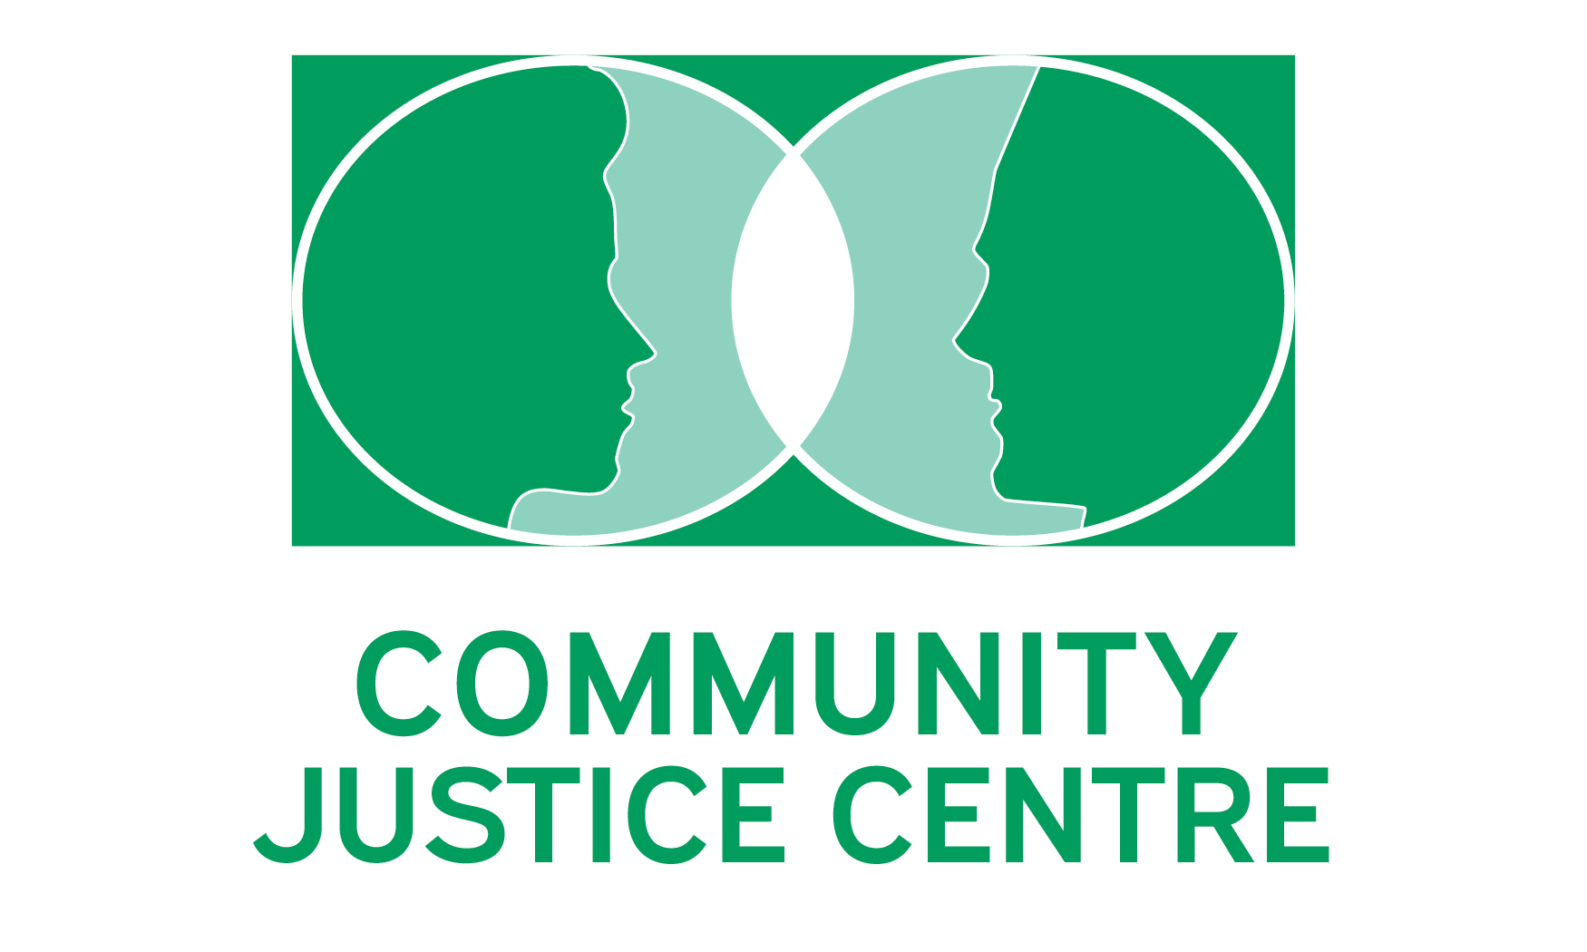

Welcome to the Community Justice Centre!

Thank you for your interest in joining the team at the Community Justice Centre (CJC). People are at the heart of our work. While this means wearing a people-centred lens in our service, it also means caring for, listening to, and empowering our volunteers.

Below you will find descriptions of our volunteer roles and the volunteer application. Once you have submitted your application, we will be in touch to answer any questions and talk you through the next steps in your application. These steps include providing us with references, participating in an interview with the Managing Director or Case Co-ordinator, obtaining a criminal record check and signing a confidentiality agreement. If you are interested in a facilitator role, the application process will involve a second interview with a trained CJC facilitator.

Once you are accepted as a volunteer, we will provide you with a welcome package, educational material, and you will begin observing resolution conferences. I will check in with you to answer any questions and hear how you are experiencing our program. New volunteers have fresh eyes and often have valuable reflections on our program to share.

Finally, if you would like to learn more about the CJC and volunteering before completing the application, please contact me. I welcome the opportunity to connect with you.

We are so thankful for your interest in sharing your time with restorative justice. Our program would not exist without volunteers.

With appreciation,

Managing Director
manager@communityjusticecentre.ca
(250) 334-8101

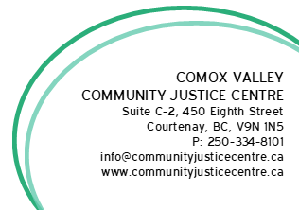

ABOUT & HISTORY OF THE CJC

The Community Justice Centre (CJC) provides conflict resolution services for the Comox Valley. We work with victims and offenders to encourage all to take responsibility for their actions, listen to others’ perspectives and to repair harm. At the end of the resolution conference, participants leave with a mutually acceptable plan to move forward. Resolution services are not therapy or group counselling. In addition to conflict resolution services, the CJC partners with other Comox Valley organizations to engage in public education initiatives.

MISSION & VALUES

CJC Mission
The Community Justice Centre (CJC) is a volunteer-powered non-profit that uses restorative justice principles and practices to support peacemaking and the resolution of conflicts for the community. This is achieved through resolution conferences, dialogue, and education.

CJC Vision
CJC envisions a safe, inclusive, resilient, and peaceful community - a community committed to respectful dialogue, compassion, and accountable and positive transformation.

Values & Principles
Community - We recognize we are interconnected and are committed to taking care of each other.

Human dignity - We work to treat everyone with respect, support, and inclusion. We believe that people make mistakes and that is not all of who they are, and that each person has intrinsic value.

Reducing and repairing harm - We believe dialogue, compassion, equity, and accountability lead to more peaceful co-existence.

Growth - Through respectful curiosity, communication, and shared learning we strengthen our humanity, humility, and connection to one another.

We recognize that we live on the unceded territory of K'ómoks First Nations. We acknowledge the impact of colonization and strive to incorporate decolonization into our work.

The values of the Community Justice Centre are applied to both external and internal relationships.

VOLUNTEER ROLES AT THE CJC

Administrative Co-ordinator
The Administrative Co-ordinator is often the first point of contact for most of our case files. This person performs receptionist functions, oversees entering and editing computer data, recording confidential information, and assists the Case Co-ordinator of the day with case file management. Most Administrative Co-ordinators volunteer one day a week for a total of three hours. When time allows, the Administrative Co-ordinator performs other helpful administrative duties.

Case Co-Ordinator
The Case Co-ordinators are responsible for the day-to-day management, supervision, and maintenance of case files. They schedule and conduct the pre-conference interviews and attend resolution conferences. During the resolution conference, they assist the Facilitator and Panel Members to achieve a fair and effective outcome. Most Case Co-ordinators volunteer one day a week for a total of three hours and attend between one and three resolution conferences a month (typically 3 hours per conference).

Facilitator
The Facilitators have the key role of supporting resolution conferences between the complainant and respondent. They ensure that all parties are heard, and a meaningful and viable agreement is reached and that the CJC process is followed. This position requires experience in the field of dispute resolution. Most resolution conferences require a 3-hour time commitment. How often you may be requested depends upon the number of cases that are currently active; how often you agree to participate depends entirely on you and your schedule. You can accept as many, or as little, as you like.

Panel Member
A key focus of restorative justice is the acknowledgment that when harm is committed, the community itself is also affected. Panel Members are members of the community who stand in and speak to the impact of the harm. They attend the resolution conferences and provide appropriate input and community knowledge to enable all parties to come to a respectful conclusion. Most resolution conferences require a 3-hour time commitment. How often a panel member may be requested to attend a conference depends upon the number of cases that are currently active; how often panel members participate also depends entirely their schedule.

Board Member
The CJC is served by a 14-member board who establishes and develop strategic directions and governing policies. The Board is a governance model (not a working board). The elected Directors serve a non-renewable term of three years. For more information, please contact the Managing Director.

Special Projects
Occasionally, we have special projects where volunteer contributions are greatly valued. Examples include, but are not limited to:

- Reviewing documents and communications materials
- Organizing our physical space
- Attending community engagement events with the Managing Director
- Anti-discrimination work
- Technology support
- Planning and setup for community education events

If you have a skill you would like to offer the CJC, please let us know. Chances are we can make use of it!

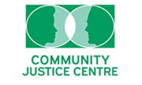

CJC VOLUNTEER APPLICATION

All information provided will solely be used for the benefit of the CJC and will not be shared with any outside organization unless required by law or ordered to be disclosed by a court.

First Name _________________________________ Last Name: ____________________

Pronouns: __________________________________

Home Mailing Address:

_______________________________________________________________________________

Telephone Number (in order of preference):
First: __________________________________

Second: _______________________________

E-mail address: _______________________________________________________
Under Bill C-28 we require your consent to send you CJC e-mails. You may unsubscribe in writing at any time.

Date of Birth (Year of birth not needed): _________________________________________

Please provide three references that we can contact:

- Name: __________________________________ Contact Email: __________________________

Relationship to you: _______________________ Years known: ________________

- Name: __________________________________ Contact Email: __________________________

Relationship to you: _______________________ Years known: ________________

- Name: __________________________________ Contact Email: __________________________

Relationship to you: _______________________ Years known: _______________

Please provide a Resume and/or Statement of Experience & Interest - if you have one.

PLEASE INDICATE YOUR AREAS OF INTEREST IF KNOWN AT THIS TIME:

- Case Co-ordinator
- Administrative Co-ordinator
- Panel Member
- Facilitator
- Board Member
- Special Projects:

- Reviewing documents and communications materials
- Organizing our physical space
- Attending community engagements with the Managing Director
- Anti-discrimination work
- Technology support
- Planning and setup for community education events.
- Other: ____________________________________________________________

AVAILABILITY: Please indicate days/times when you are not available:

Signature: ___________________________________ Date: ______________________

If at any time, you also wish to become a member of the Community Justice Centre of the Comox Valley Society the membership dues are ten dollars ($10.00).

PERMISSION TO PERFORM REFERENCE CHECK

I hereby give permission to the Community Justice Centre to check of my references, including:
- Educational/ professional status,
- Past employment/ volunteer history, and
- Personal references.

I understand that I do not have to agree to this reference check, but that refusal to do so may exclude me from being considered as a volunteer with this society.

I understand that information collected during this reference check will be limited to that appropriate to determining my suitability for particular types of work and that all such information collected during the check will be kept confidential.

I hereby also extend my permission to those individuals or organizations contacted for the purpose of this reference check to give their full and honest evaluation of my suitability of the described volunteer work, and such information as they deem appropriate.

In addition, I consent to a copy of my Criminal Record Check, performed by the RCMP, to be kept in my volunteer file. I understand that I need to update my Criminal Record Check every 5 years for me to stay active as a CJC Volunteer.

Signature: ___________________________________ Date: ______________________

